BIT 4107 – Mobile Application Development
ENHANCED PROFESSIONAL STUDENT LOGBOOK
Student Name: yvonne mwende njeru
Admission Number: _BIT/2024/60085
School/Faculty: science
Programme : degree
Academic Year: 2024
Semester: 3
Lecturer: Michael Nyoro
Phone Number: 0799995976

Table of Contents
1.0 Week 1: Introduction to Mobile Application Development 3
1.1 Practical Activities Undertaken 3
1.2 Tools/Software Used 3
1.3 Personal Reflection 3
2.0 Week 2: Mobile Development Environment 4
Week 3: User Interface Design 5
4.0 Week 4: Event Handling and User Interaction 6
5.0 Week 5: Data Management 10
6.0 Week 6: Networking and APIs 12
7.0 Week 7: Application Architecture 14
Week 8: Project Planning 16
Week 9: Device Features and Sensors 17
Week 10: Notifications and Background Services 18
Week 11: Mobile Security 19
Week 12: Testing and Debugging 19
Week 13: Application Deployment 19
Week 14: Final Project Presentation 19
Semester Project Tracking 19
End of Semester Reflection 21
Final Approval 21

1.0 Week 1: Introduction to Mobile Application Development

1.1 Practical Activities Undertaken
Flutter mobile application project structure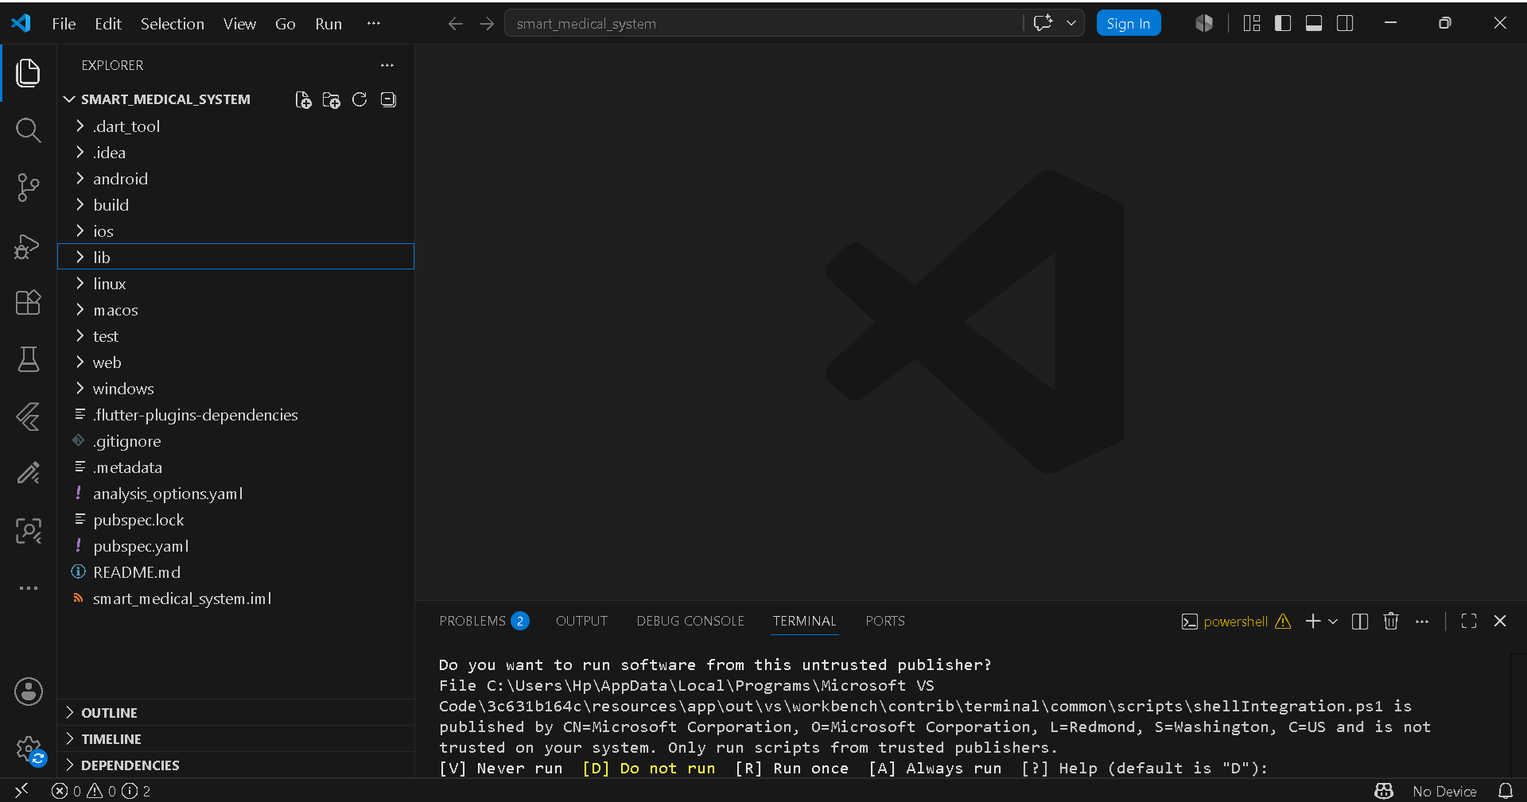

1.2 Tools/Software Used
• Flutter
• VS Code
• Android Studio

1.3 Personal Reflection
I learned how to create a Flutter mobile application project structure and understand the main folders required for development.

2.0 Week 2: Mobile Development Environment
Flutter development environment configuration
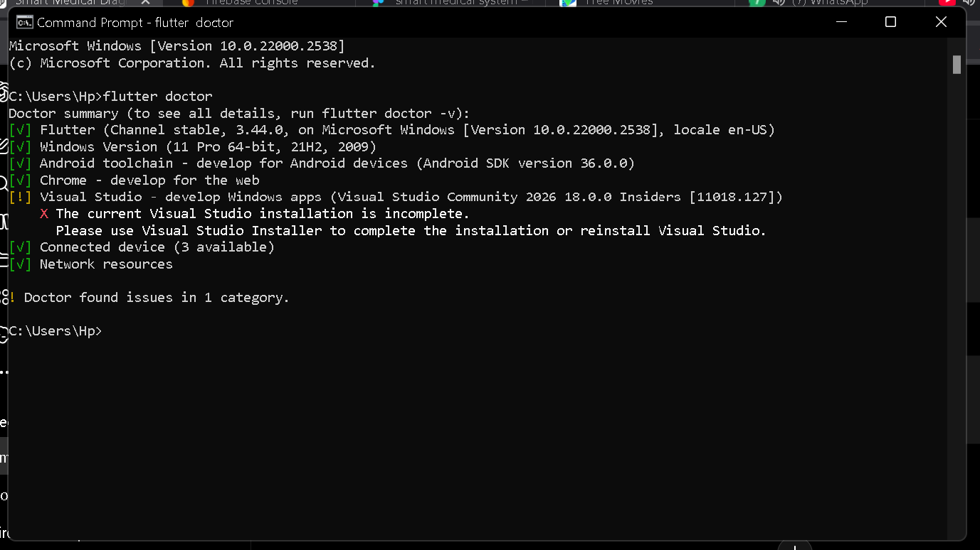

Week 3: User Interface Design
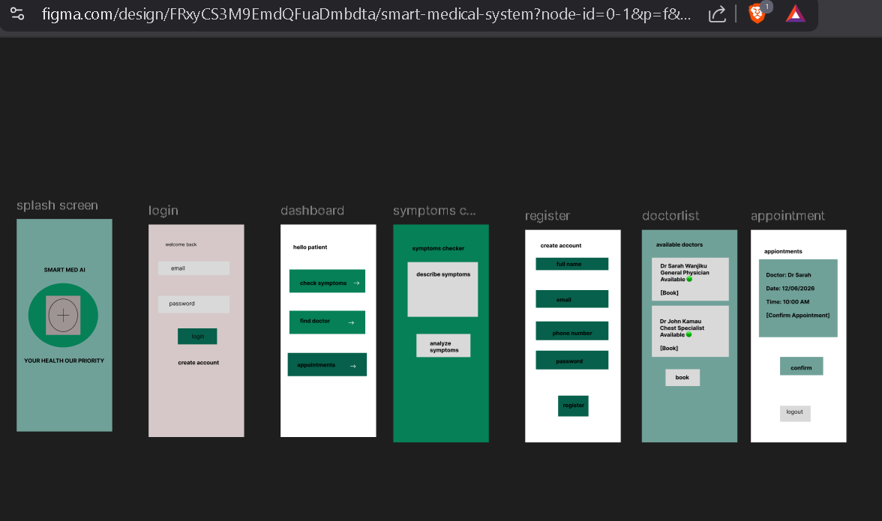

4.0 Week 4: Event Handling and User Interaction
4.1Login page

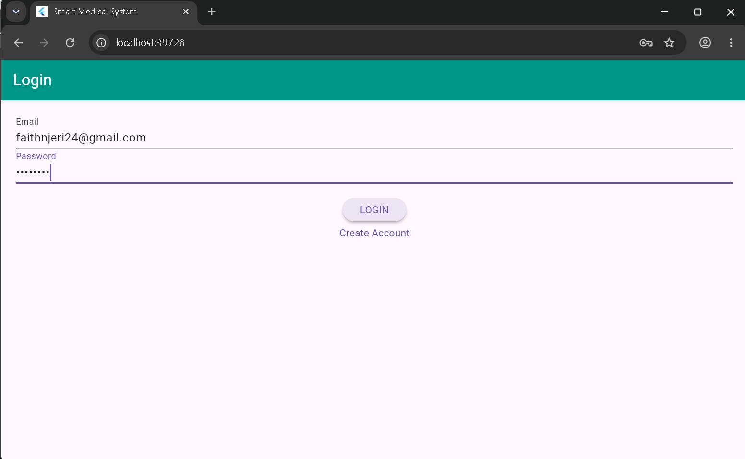
4.2 dashboard page

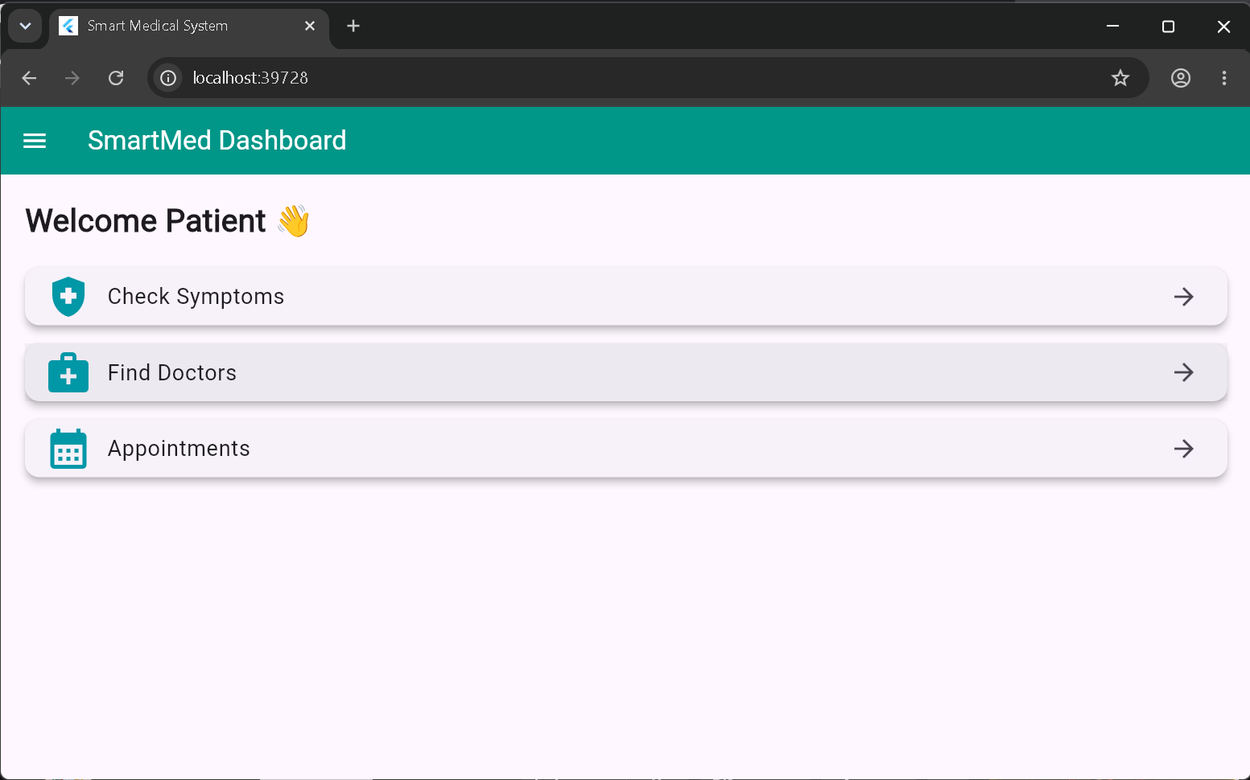
4.3 Symptom checker

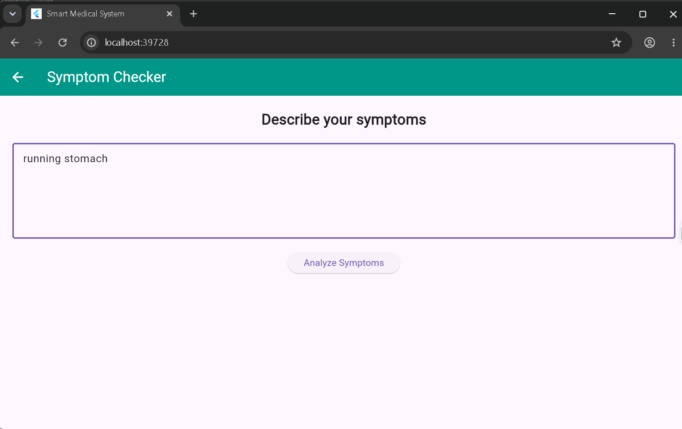
4.4 results diagnosis
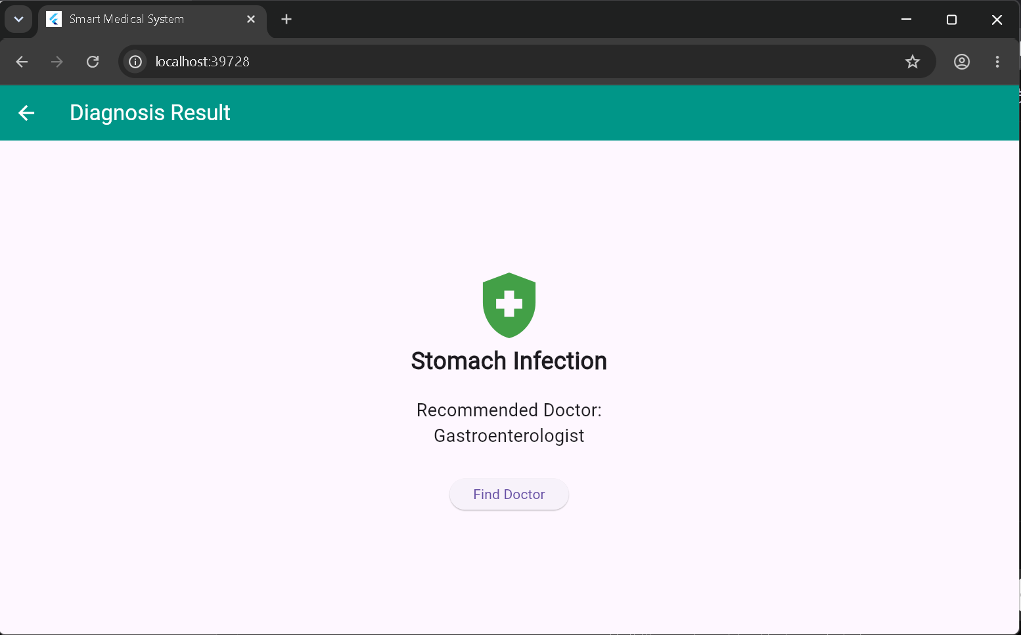

4.5 doctors available
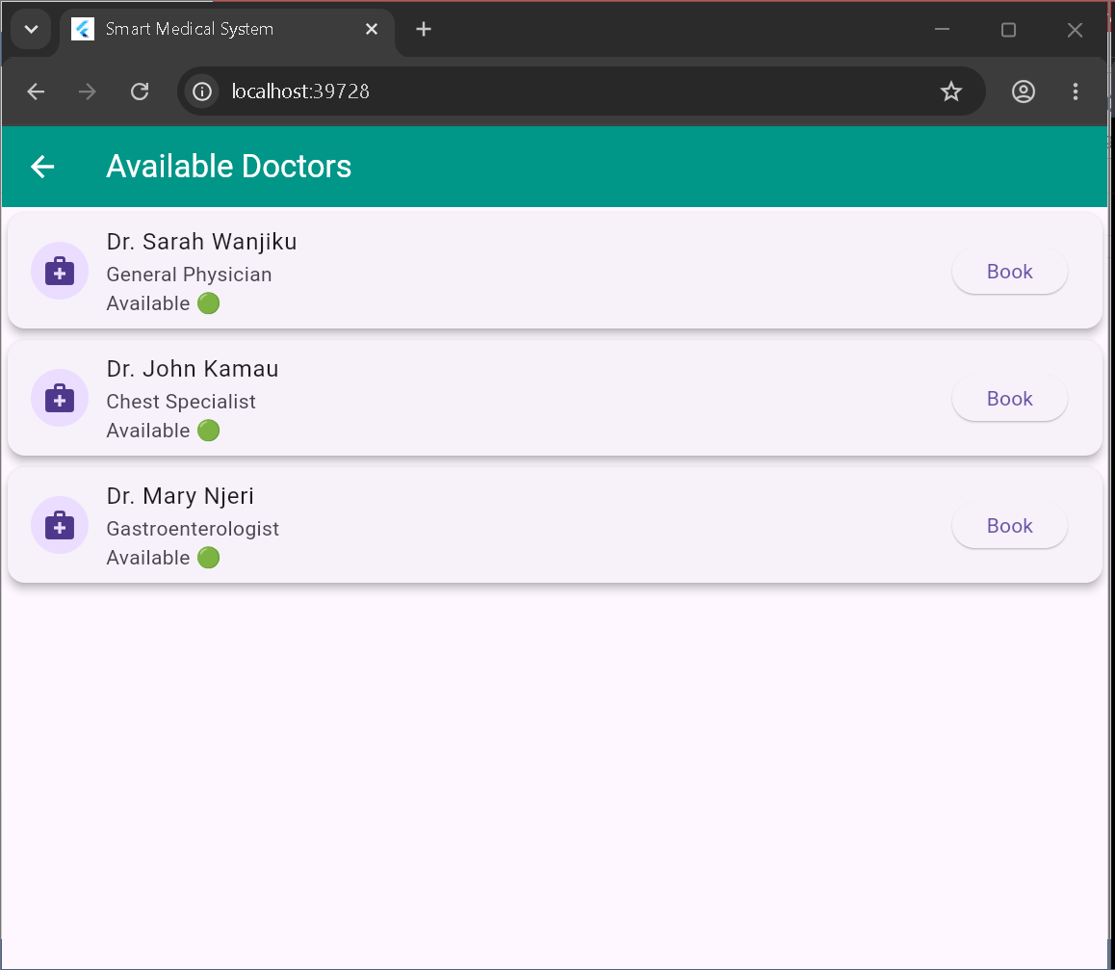
4.6 booking appointment
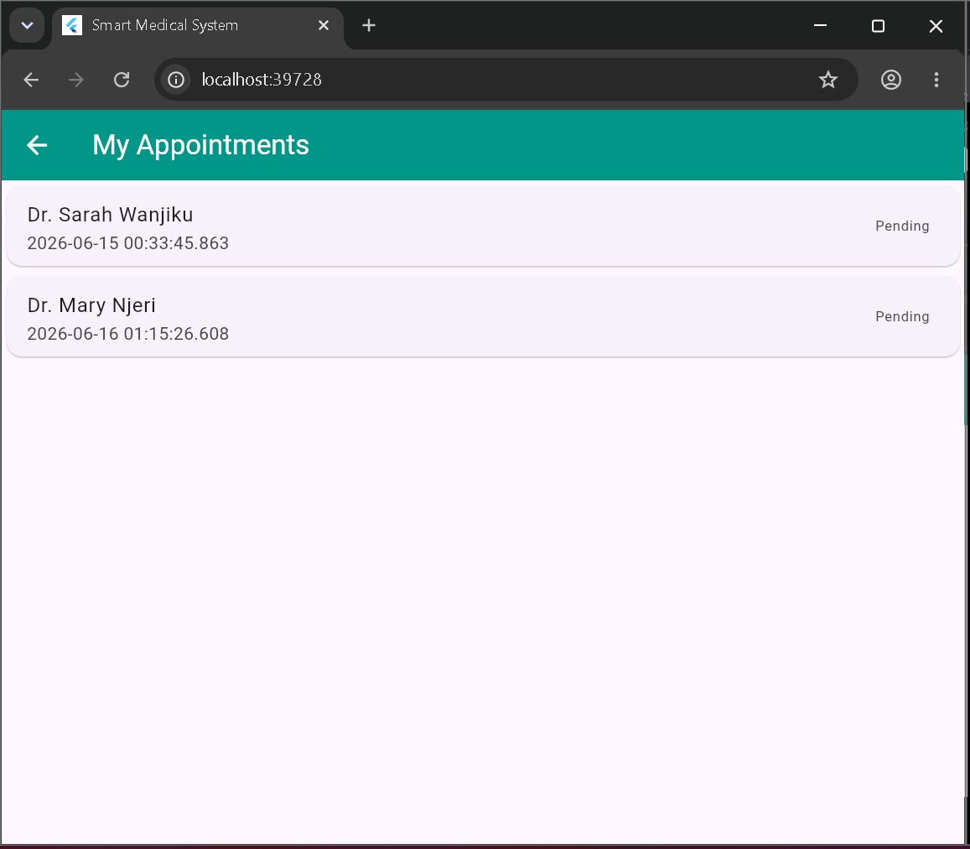
4.7 pending appointments

4.8 logout
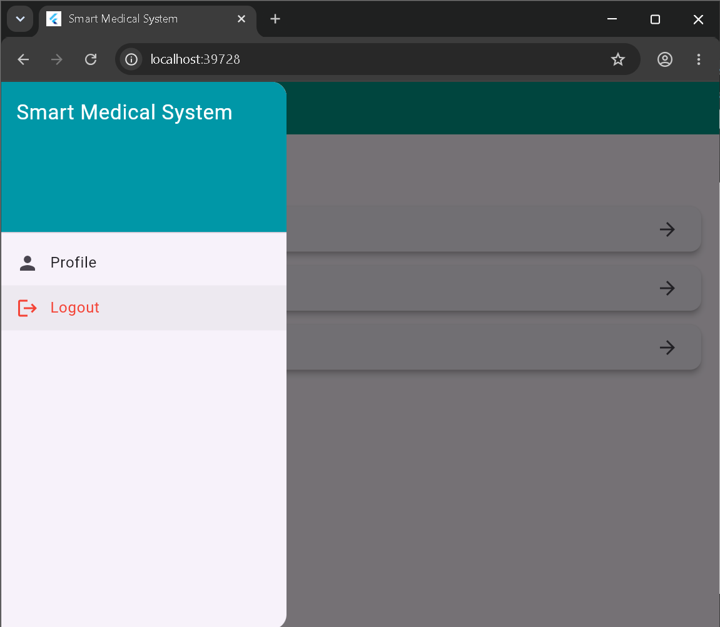

5.0 Week 5: Data Management
5.1Firestore Database

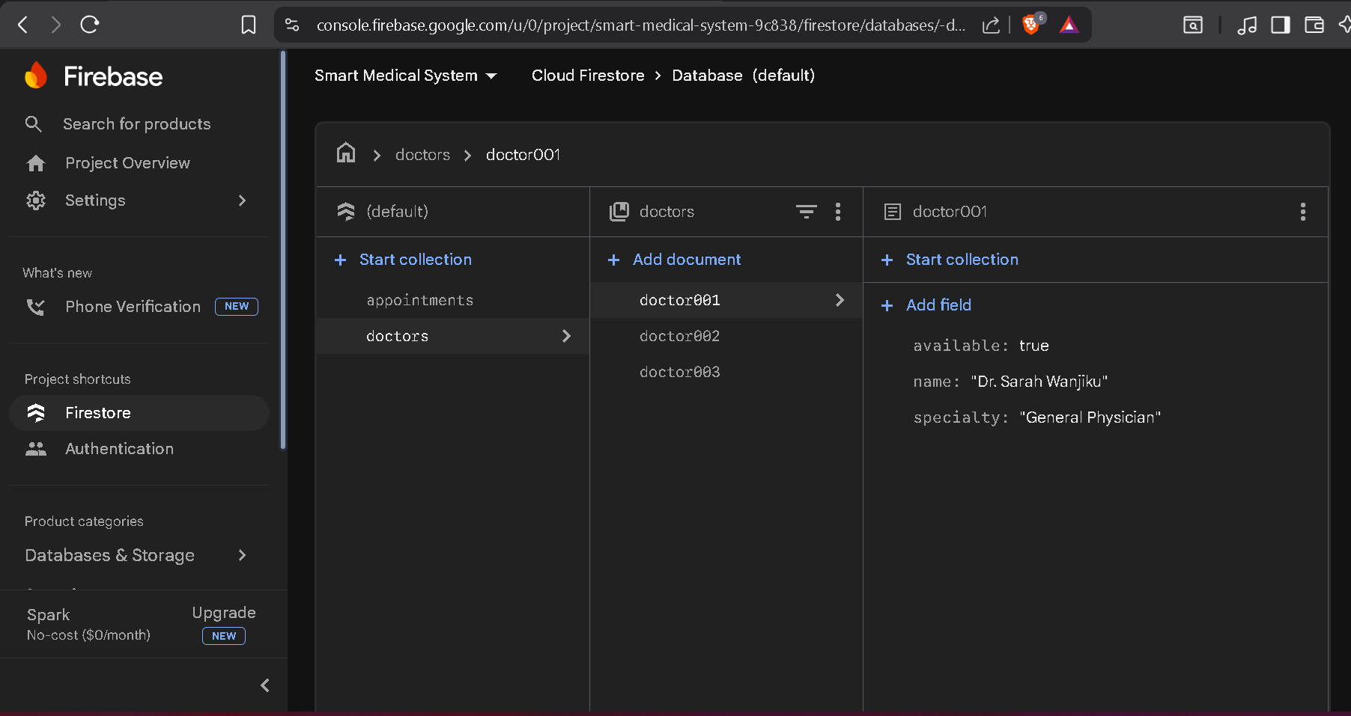
5.2 Firestore Database

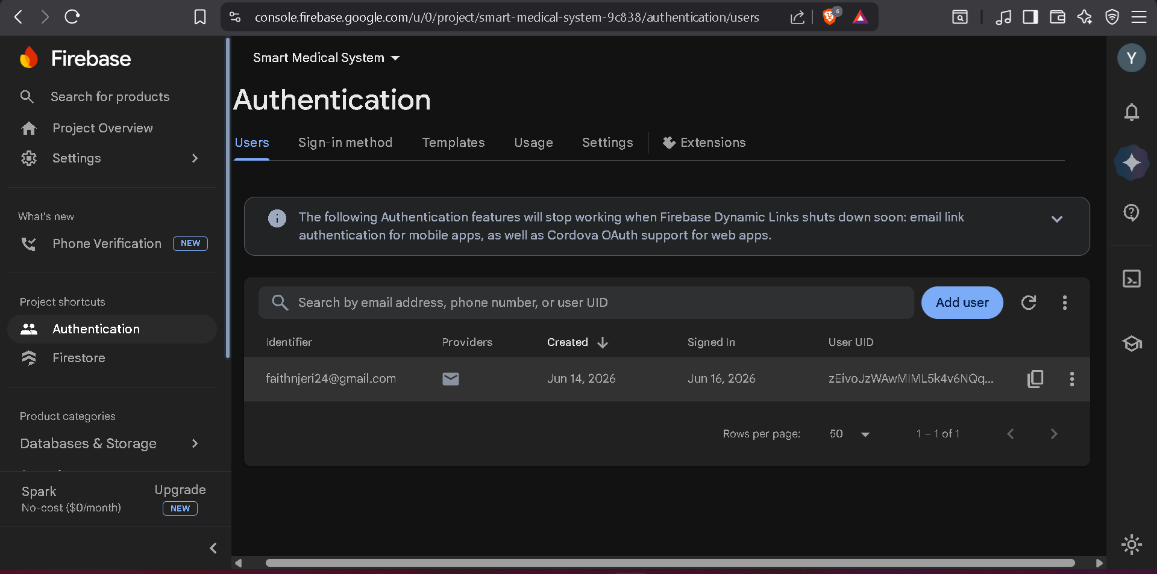
5.3 Firebase Firestore database collections
Doctors record
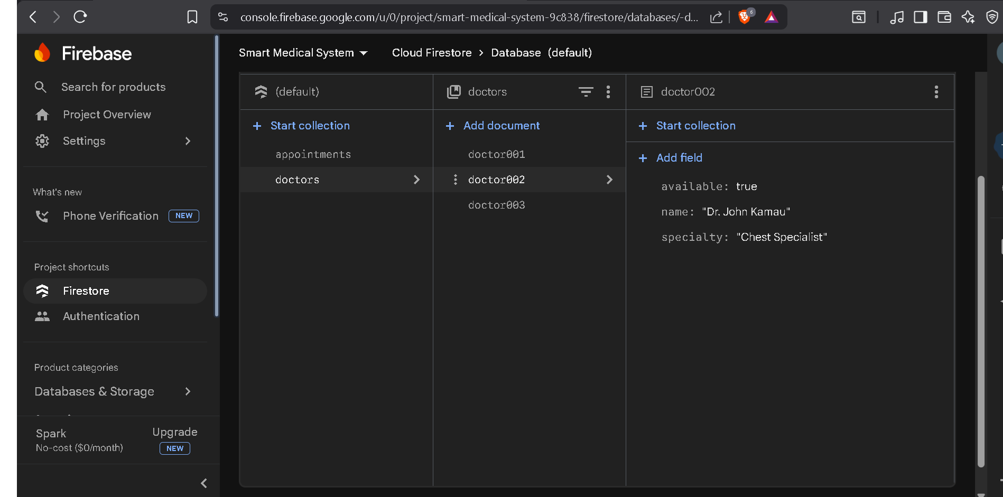

6.0 Week 6: Networking and APIs
6.1Firebase API initialization code
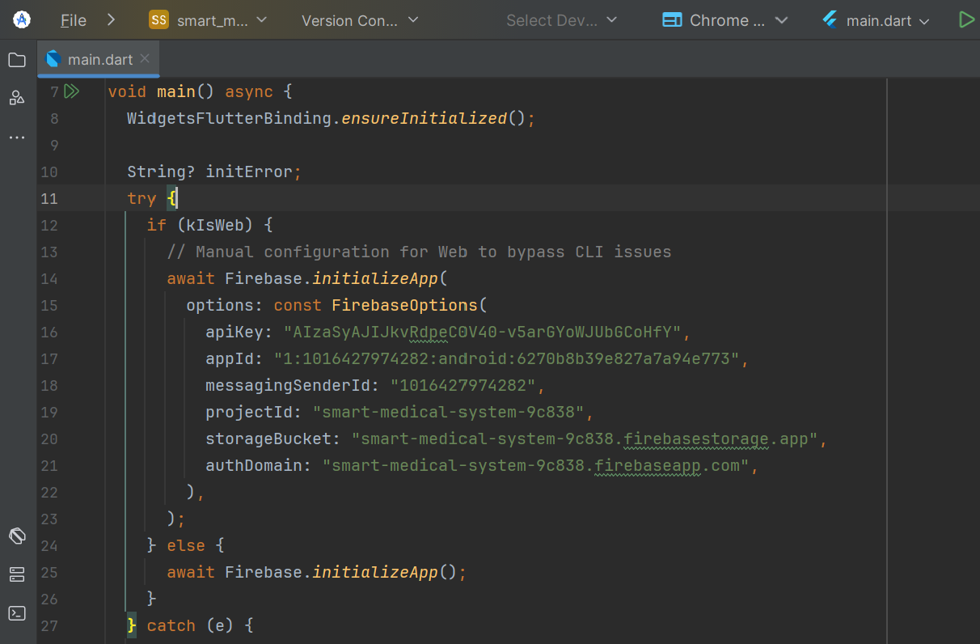
6.2 Internet permission configuration for API communication
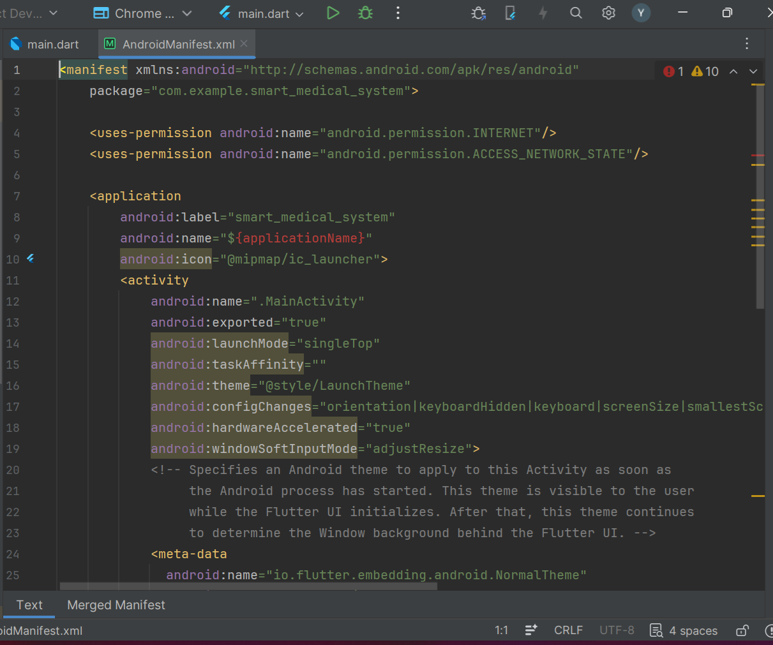
6.3Internet permission configuration for API communication
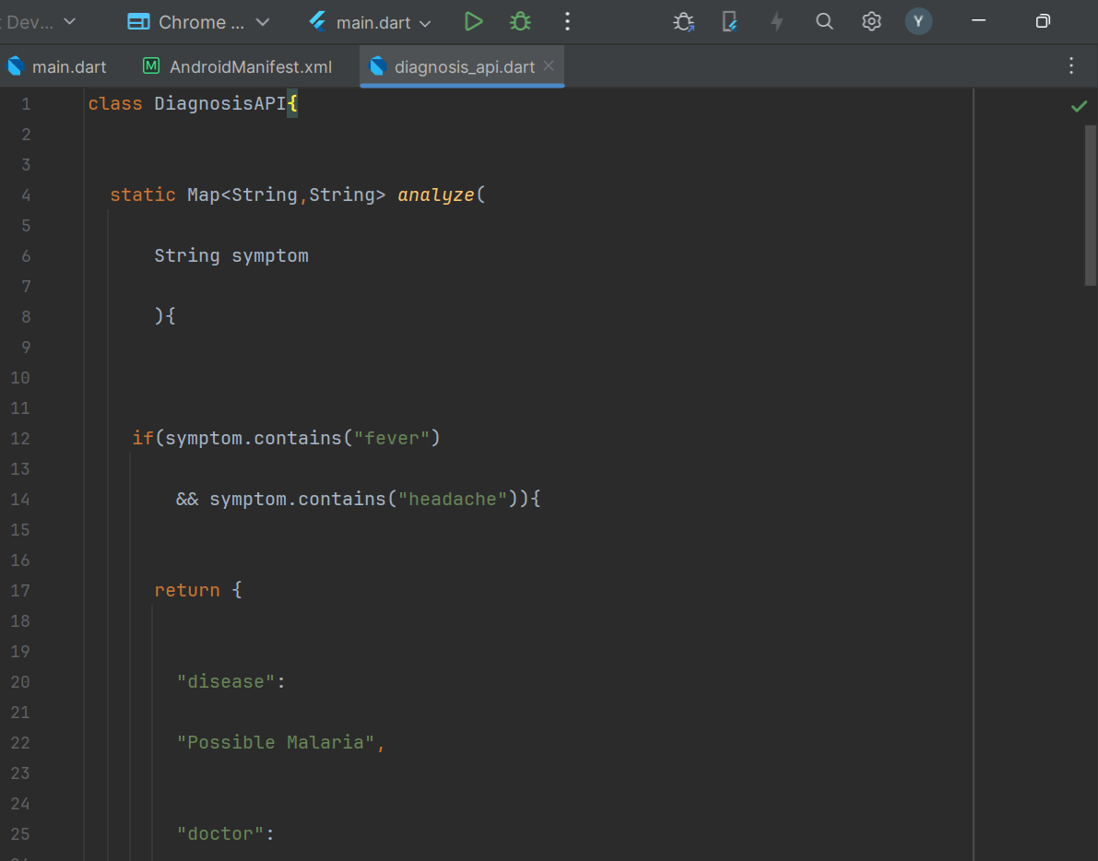

7.0 Week 7: Application Architecture
7.1 Flutter application architecture structure
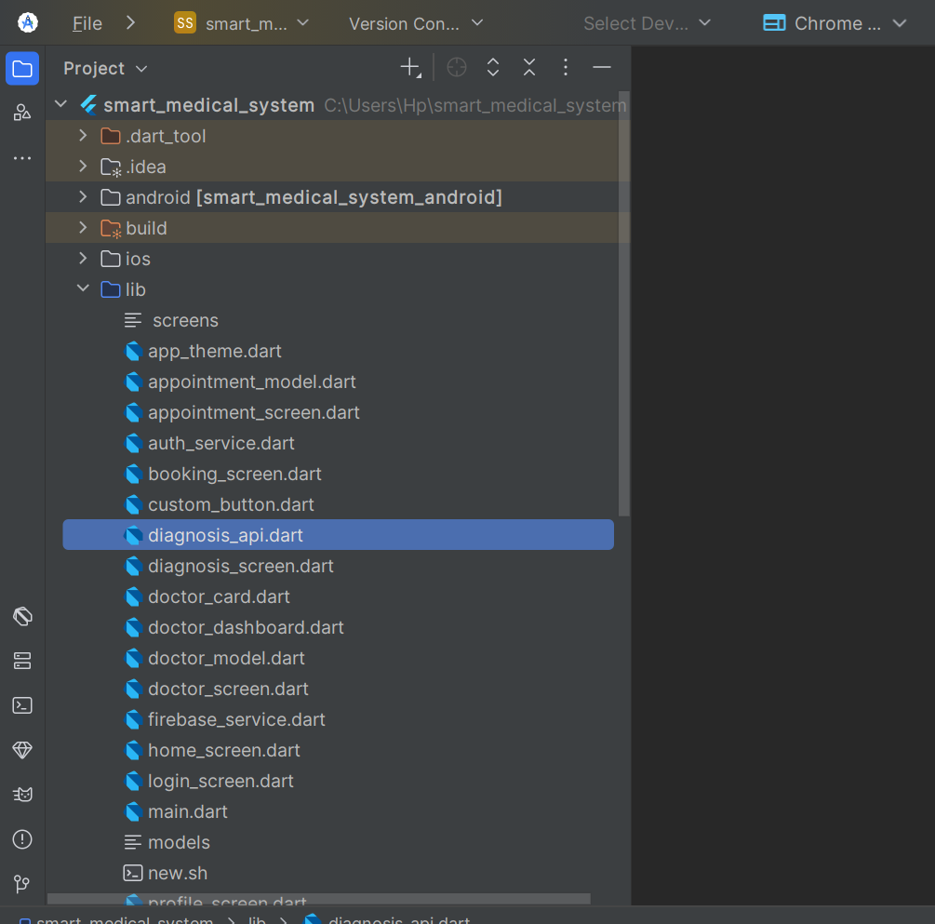

Week 8: Project Planning

Week 9: Device Features and Sensors

Week 10: Notifications and Background Services
Same as week 1

Week 11: Mobile Security
Same as week 1

Week 12: Testing and Debugging
Same as week 1

Week 13: Application Deployment
Same as week 1

Week 14: Final Project Presentation
Same as week 1

Semester Project Tracking
Project Title

Project Objectives

Project Requirements

Development Milestones

Testing Results

Lessons Learned

Future Improvements

End of Semester Reflection
Summary of Skills Acquired

Most Interesting Topic

Major Challenges Faced

How Challenges Were Overcome

Professional Growth Achieved

Overall Course Experience

Final Approval
Student Name: __________________________
Student Signature: ______________________
Date: _________________________________
Lecturer Name: _________________________
Lecturer Remarks: _____________________
Date: _________________________________

